Product and Category Management System
Database Design & Implementation Report (MySQL)

1. Task Overview
This report documents the design and implementation of a Product and Category Management System using MySQL Workbench. The objective of this task was to design a relational database that stores product and category information, enforce referential integrity through primary and foreign keys, and demonstrate core database operations including insertion, updating, deletion, and reporting.
The task was carried out in the following steps:
- Designing tables for the Product and Category entities.
- Defining primary key and foreign key relationships between the tables.
- Storing product details such as name, category, price, and stock.
- Performing product insertion, updating, and deletion operations.
- Generating a category-wise product report using a JOIN query.

2. Database and Table Design
A new database named ProductDB was created, and two tables — Category and Product — were designed within it. The Category table stores the list of product categories, while the Product table stores individual product records. A foreign key relationship was established between the two tables using the category_id column, linking each product to its respective category.
SQL used to create the database and tables:
CREATE DATABASE ProductDB;
USE ProductDB;

CREATE TABLE Category (
category_id INT PRIMARY KEY,
category_name VARCHAR(50)
);

CREATE TABLE Product (
product_id INT PRIMARY KEY,
product_name VARCHAR(100),
category_id INT,
price DECIMAL(10,2),
stock INT,
FOREIGN KEY (category_id) REFERENCES Category(category_id)
);
In this design, category_id is the Primary Key of the Category table and product_id is the Primary Key of the Product table. The category_id column in the Product table acts as a Foreign Key, referencing category_id in the Category table. This enforces referential integrity, ensuring that a product cannot be assigned to a category that does not exist.
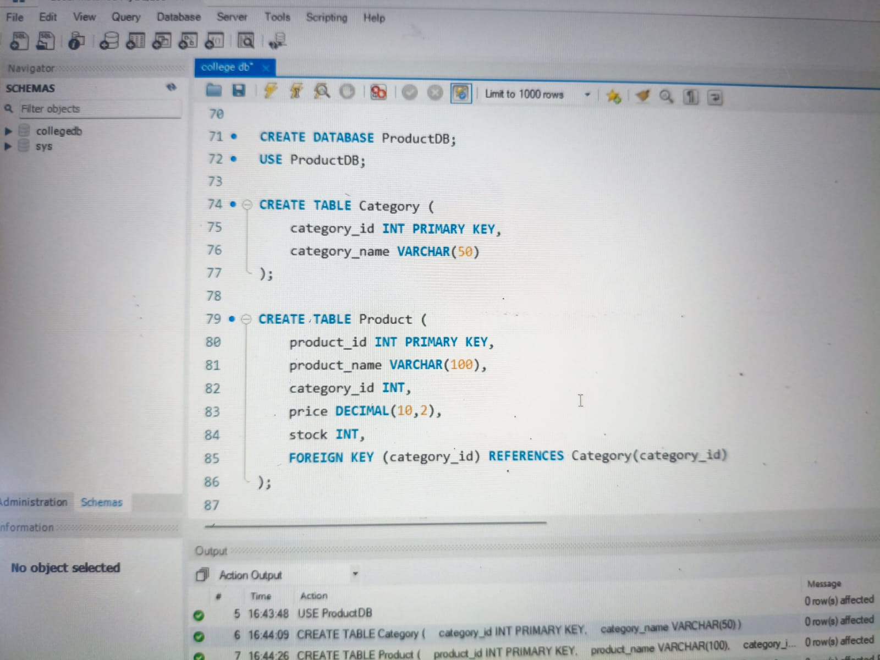
Fig. 1 — Creating the ProductDB database and the Category and Product tables with a primary/foreign key relationship.

3. Storing Product and Category Data
Once the tables were created, sample data was inserted into both tables using INSERT INTO statements. Three categories (Electronics, Clothing, Grocery) and five products were added, with each product linked to its category through the category_id foreign key.
INSERT INTO Category (category_id, category_name)
VALUES
(1, 'Electronics'),
(2, 'Clothing'),
(3, 'Grocery');

INSERT INTO Product (product_id, product_name, category_id, price, stock)
VALUES
(101, 'Laptop', 1, 55000, 10),
(102, 'Mobile Phone', 1, 25000, 20),
(103, 'T-Shirt', 2, 800, 50),
(104, 'Jeans', 2, 1500, 30),
(105, 'Rice', 3, 1200, 25);
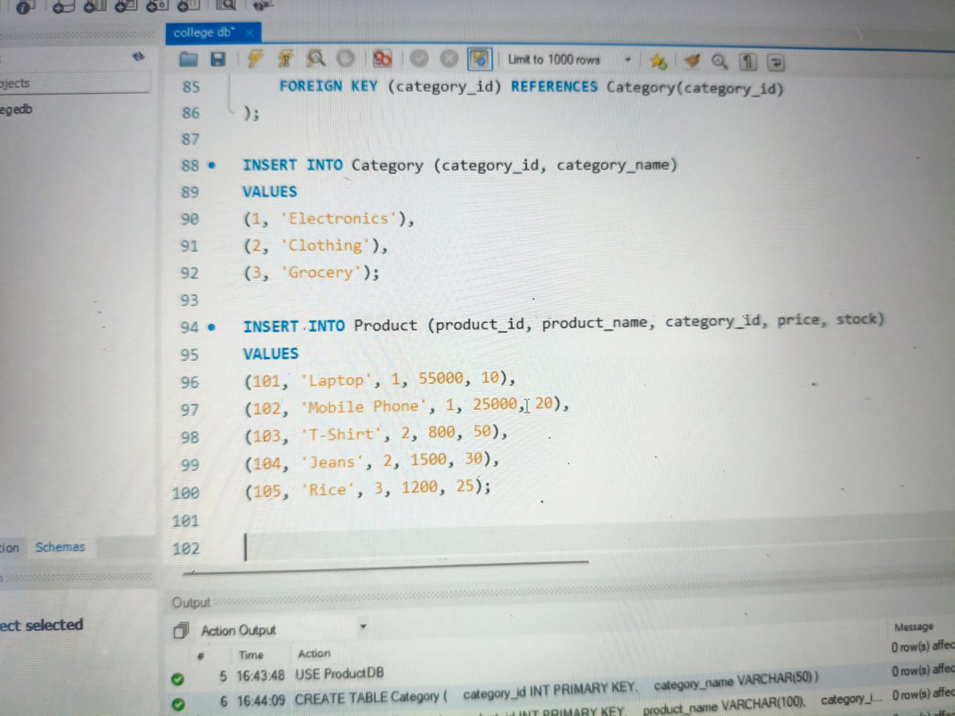
Fig. 2 — Inserting category records and product records into the Category and Product tables.
The inserted data was then verified by querying each table individually with a SELECT statement.
SELECT * FROM Category;
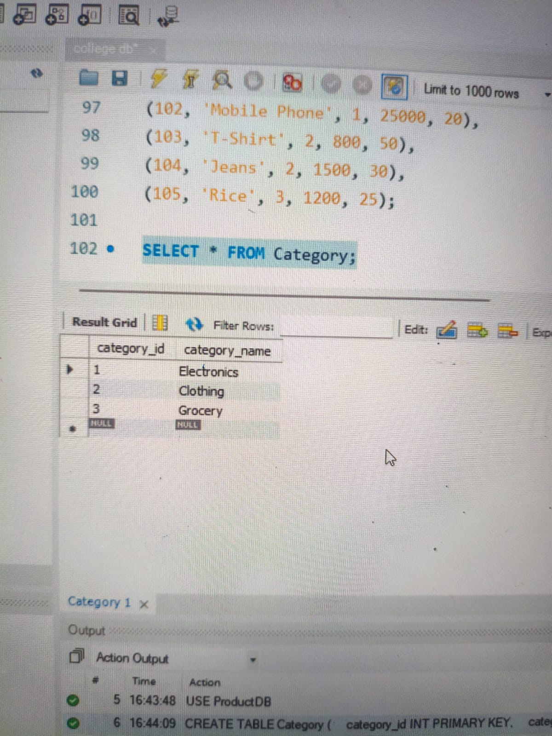
Fig. 3 — Verifying the Category table data: category_id and category_name for Electronics, Clothing, and Grocery.
SELECT * FROM Product;
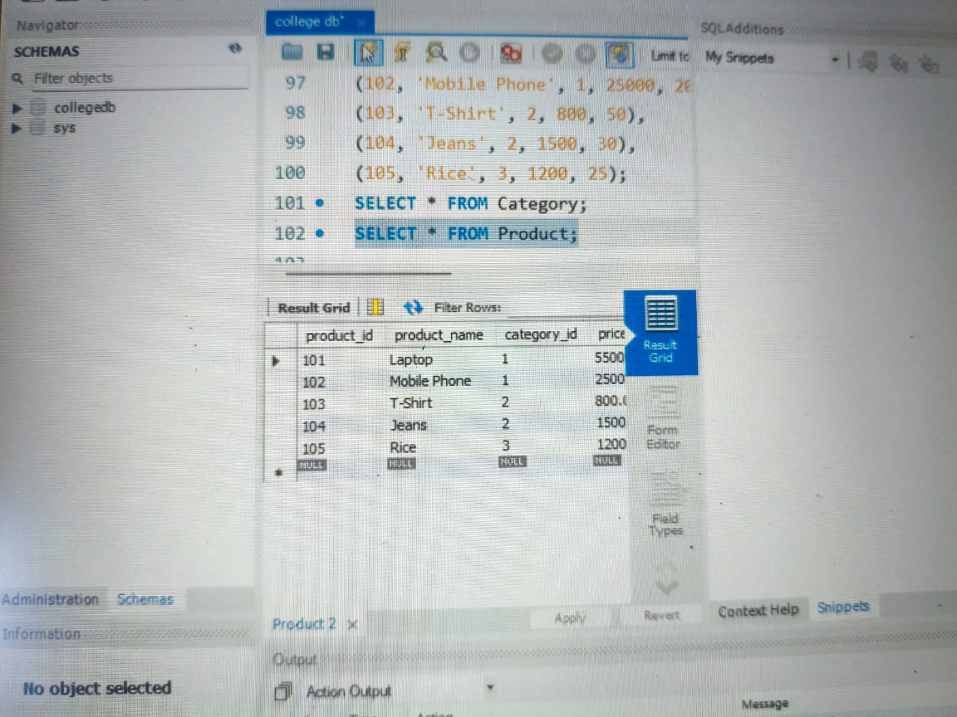
Fig. 4 — Verifying the Product table data: product_id, product_name, category_id, price, and stock.
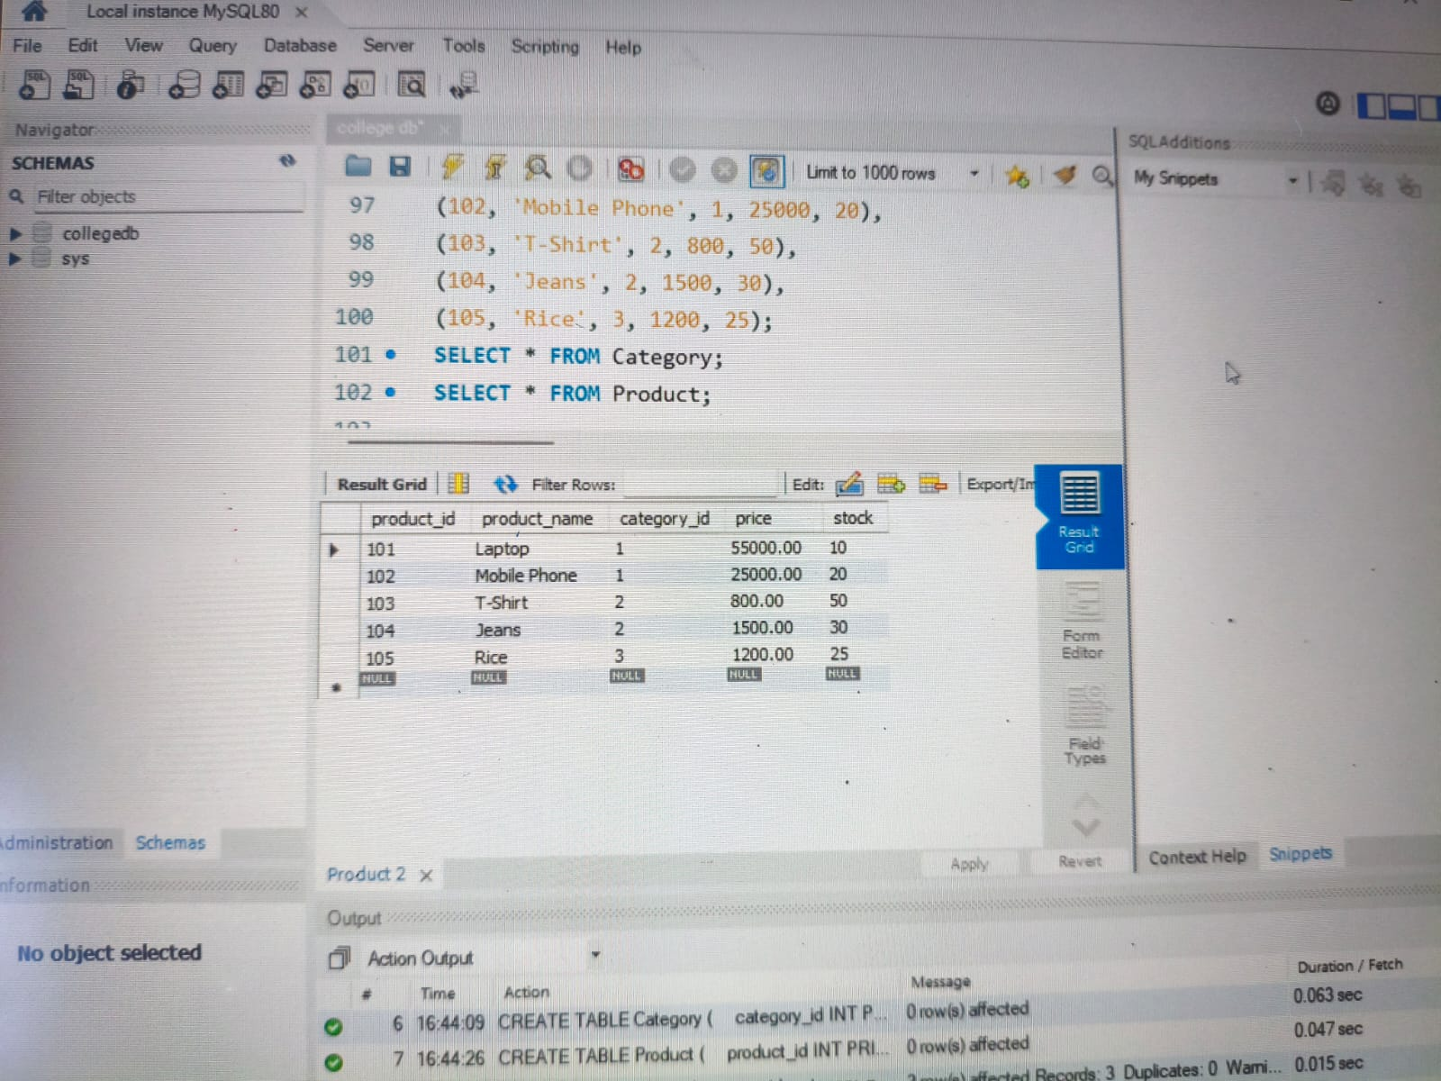
Fig. 5 — Full result grid of the Product table, showing all five inserted products with their category, price, and stock values.

4. Product Insertion, Updating, and Deletion
After the initial data was inserted, UPDATE and DELETE operations were performed to demonstrate the system's ability to modify and remove product records.
Updating the price of the Laptop (product_id = 101):
UPDATE Product
SET price = 58000
WHERE product_id = 101;
Deleting the Jeans product (product_id = 104):
DELETE FROM Product
WHERE product_id = 104;
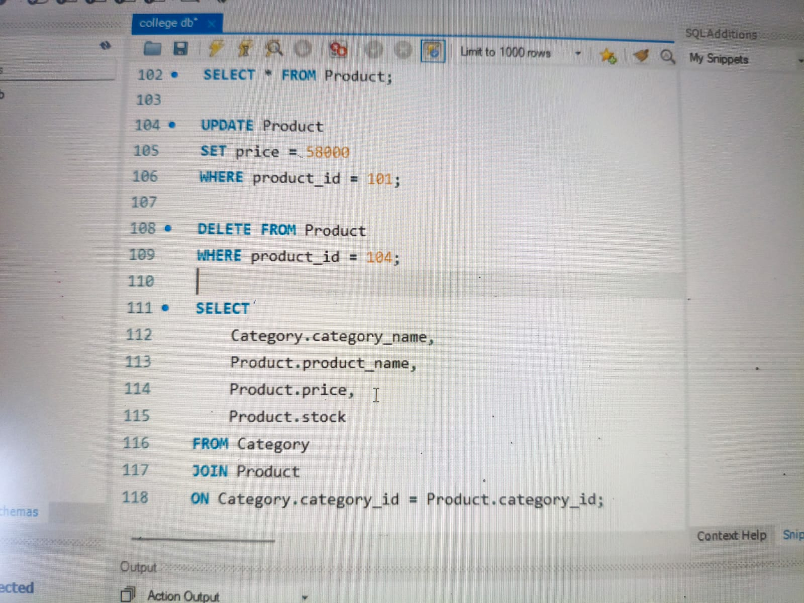
Fig. 6 — UPDATE query changing the Laptop price to 58000, followed by a DELETE query removing the Jeans record.

5. Category-wise Product Report
Finally, a category-wise product report was generated by joining the Category and Product tables on the category_id column. This query lists each product alongside its category name, price, and stock, giving a consolidated view of the inventory.
SELECT
Category.category_name,
Product.product_name,
Product.price,
Product.stock
FROM Category
JOIN Product
ON Category.category_id = Product.category_id;
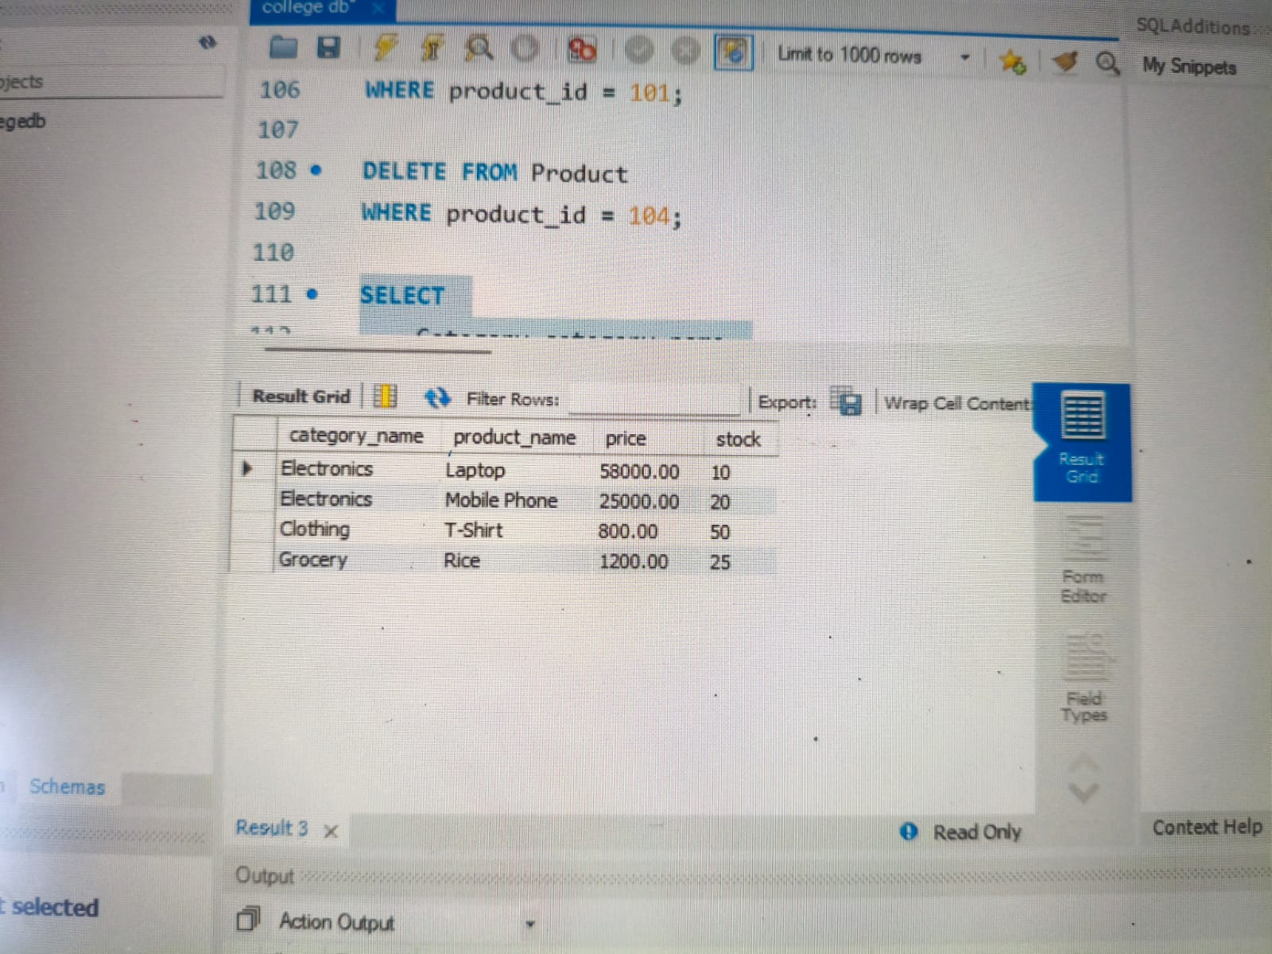
Fig. 7 — Category-wise product report generated using a JOIN query, showing the updated Laptop price (58000) and the Jeans record removed after deletion.

6. Conclusion
The Product and Category Management System was successfully designed and implemented in MySQL Workbench. The Category and Product tables were created with an appropriate primary key and foreign key relationship, sample data was inserted and verified, and UPDATE and DELETE operations were carried out to modify the records. Finally, a JOIN query was used to generate a category-wise product report, confirming that the relational design correctly links products to their categories and supports all required database operations.

